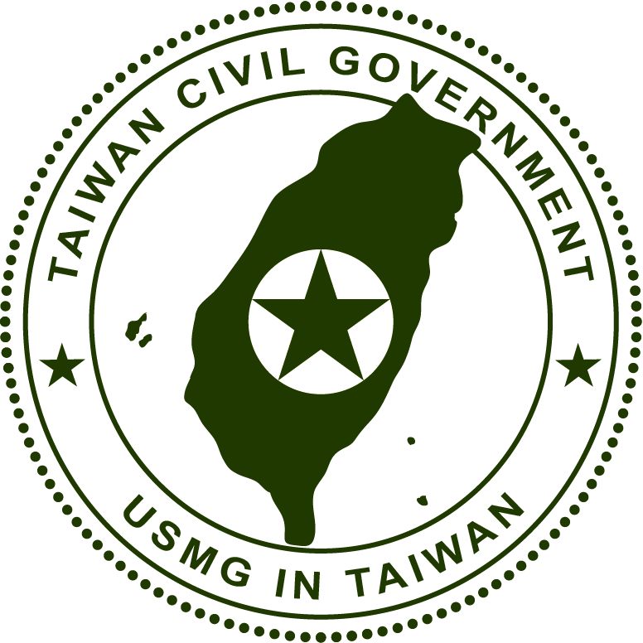
1250 Connecticut Avenue, N.W.
Suite 200
Washington, D.C. 20036

August 9, 2011
To: Ms. Ileana Ros-Lehtinen (R-FL), Chairman
House Committee on Foreign Affairs
2170 Rayburn House Office Building
Washington, DC 20515

Dear Madam Chairman,

In your June 16, 2011 Hearing on Taiwan, many Representatives were very vocal in their support for the sale of F-16 jet fighters and other military equipment to Taiwan. Among these were Representatives Ileana Ros-Lehtinen, Howard Berman, David Rivera, Gerry Connolly, Eni Faleomavaega, Steve Chabot, and others.

In reviewing the Taiwan Relations Act (TRA) passed by the US Congress in 1979, I see that the TRA mandates that the United States “provide” or “make available” sufficient weapons for Taiwan’s self-defense. While no one doubts that this is the law of the land in the United States, I do believe that it is necessary to examine the legal foundation on which the TRA rests.

Specifically, the military hardware and other weapons which the United States makes available to Taiwan are used by an organization which calls itself the “Republic of China Ministry of National Defense (ROC MND).” Under the authority of this organization, since the early 1950s (and by some accounts even earlier) mandatory military conscription policies for male Taiwanese youth have been in place. Criminal penalties for non-compliance are very harsh.

While no one doubts the appropriateness of mandatory military conscription policies in sovereign nations, the Republic of China (ROC) does not fit in this category. The Sept. 2008 “Mandatory Guidance from Department of State Regarding Contact with Taiwan” clearly state that:
Consistent with the unofficial nature of US – Taiwan ties, the US government does not refer to Taiwan as the “Republic of China,” the “Republic of China on Taiwan,” or a country.

Earlier, on Oct. 25, 2004, (former) United States Secretary of State Colin Powell elaborated on the United States' continuing policy towards Taiwan. He stated, "Taiwan is not independent. It does not enjoy sovereignty as a nation, and that remains our policy, our firm policy."

The BACKGROUND to the State Department’s many policy announcements may be found in the historical record.
According to my understanding, since the end of fighting in 1945, it has been the official policy of the United States government that the status of Taiwan is "an unsettled question . . . . " No doubt this is because the Oct. 25, 1945, surrender of Japanese troops on the island only marked the beginning of the military occupation, and international law specifies that “military occupation does not transfer sovereignty.” Additionally, in the post-war San Francisco Peace Treaty which came into effect on April 28, 1952, although Japan renounced all right, title, and claim to “Formosa and the Pescadores,” the territorial sovereignty of these areas was not awarded to “China.” Hence, it can be argued that Taiwan has remained as “occupied territory” up to the present day.

Under such circumstances, I must ask: Where is the legal basis for the imposition of mandatory military conscription policies over the native Taiwanese populace by the ROC regime? Aren’t such military conscription policies a violation of the Geneva and Hague Conventions? Unfortunately, the Representatives who continually voice their support for arms sales to Taiwan have (to my knowledge) never researched these questions.

Some important data regarding this entire matter has recently become available on the internet, in the form of a listing of legal and quasi-legal documents which have some bearing on the Taiwan’s international legal status. However, according to the evaluation of all researchers with whom I have been in touch, none of these can serve as a legal basis for the implementation of military conscription laws over the native Taiwanese populace by the "Republic of China" regime in Taiwan. Please see –
http://www.taiwanadvice.com/military-cons.htm

It is my understanding that the House Committee on Foreign Affairs may hold a further Hearing regarding Taiwan in September 2011, or later in the Fall. May I make a request? Could a representative from the Dept. of Defense or Dept. of State please provide an in-depth analysis of the official US government viewpoint on this important topic?? Specifically, what is the legal basis for military conscription laws (by the ROC regime) in Taiwan? Certainly this is an essential matter to consider in relation to the operations of a "Republic of China" military establishment on Taiwanese soil, and US sales of military equipment to the ROC MND. Indeed, under US law, and specifically the TRA, the appellation of “Republic of China” is not recognized after Jan. 1, 1979. This non-recognition is also in full conformance with the “One China Policy” as espoused by the US Executive Branch.

Let us not forget that the TRA discusses "human rights" in some detail, see 22 USC 3301 (c) Human rights
Nothing contained in this chapter shall contravene the interest of the United States in human rights, especially with respect to the human rights of all the approximately eighteen million inhabitants of Taiwan. The preservation and enhancement of the human rights of all the people on Taiwan are hereby reaffirmed as objectives of the United States.

Certainly, military conscription into a rebel Chinese regime (of questionable legal validity) is a gross violation of the human rights of all native Taiwanese persons. Hence, I believe that the native Taiwanese people are entitled to a detailed answer to this military conscription question. Furthermore, I would urge that all arms sales to the ROC regime should be suspended until a legal justification for ROC military conscription in Taiwan can be found.

Sincerely,

Roger C. S. Lin
No.100-1, Yuanlinkeng Road, Guishan Township,
Taoyuan 333, Taiwan

P.S. Further information on my lawsuit against the US government is included on a separate page, as below.

Roger C. S. Lin v. United States of America
filed in the United States District Court, Washington, D.C. on Oct. 24, 2006

Summary:

This was a legal action by a group of native Taiwanese people, led by Dr. Roger C. S. Lin, suing the US government in regard to its mishandling of the Taiwan issue in the post-WWII period.

Results of the lawsuit were as follows:

The District Court in Washington D.C. (March 18, 2008) held that --
Plaintiffs have essentially been persons without a state for almost 60 years.

The Court of Appeals in Washington D.C. (April 7, 2009) held that --
America and China's tumultuous relationship over the past sixty years has trapped the inhabitants of Taiwan in political purgatory. During this time the people on Taiwan have lived without any uniformly recognized government.

For more information, see -- http://www.civil-taiwan.org/lin-v-usa.htm

Please also take note of the recent editions of the US State Dept. publication Treaties in Force, in which it is clearly noted that "The United States does not recognize the Republic of China as a state or a government."

